**Create an AWS EC2 instance to Host a Website using APACHE Web Server**

We need to create first ec2 instance of AMI Linux Server and allow security to connect with ssh with putty for connection.

So here we need to follow the steps thoroughly

1. Open the **“AWS Console dashboard”**
2. Click : “**launch instance”**
3. Configure the Instance details --- **“name , AMI (Amazon Linux ),type , key pair- ppk, storage , networking settings including security –https ,http ,ssh**
4. Click :- **launch instance.**

**After completing successfully launching the instance and now we will need to connect the instance with ssh port on any remote connection software.**

**For logging into server apache server ssh credentials and ip**

**Enter Public IPv4 address**

**3.216.90.99 |**[**open address**](https://3.216.90.99/)

**Enter also ssh –**

**Credentials**

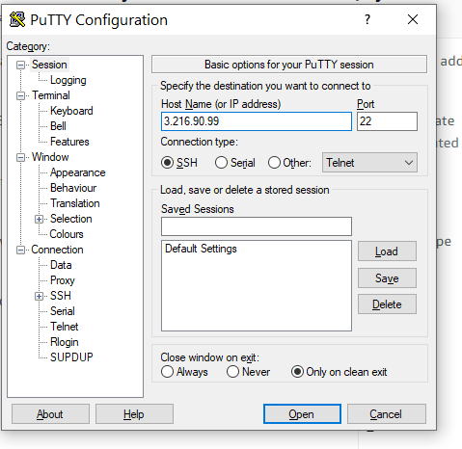

**After logging into apache server,**

**Login as: ec2-user**

* **$--- sudo -i ------------------------------- this command uses to switch to admin user who can run all command in Linux with full permission**

**- Install apache service in Amazon Linux machine-- to make thos server as web server:-**

* **# yum install httpd* -**

**---------- This is the command to install apache in linux once you enter it will verify all package)**

* **Is this ok [y/N]: y**

**(after verify all package it will ask us to Yes or No to install the apache so we have to press Y)**

* **rpm -qa**

**( this is the command RPM(redhat package manager) QA- query All the httpd packge list)**

**Now how to start my apache service and http protocol in my Web server after apache installation--**

* **$ service httpd start**

**------ ( this is the command to start the apache) or you can use systemctl**

**command also)**

* **# service httpd status**

**---- (this command is showing the status that apache starte or not in our**

**server)**

**To check or listening the http(80) port in server run below command:-(netstat -a**

* **# netstat -a**

**How to deploy your website :-**

* **so we have document ll**
* **/var/www/html**

**------- where we can store our code file like html,php page**

* **# cd /var/www/html/**

**- We need to go inside of this directory and make changes**

* **# echo "My First Web Page" > index.html**
* **-------then add some content inside of this new index.html file**
* **[root@ip-172-31-12-249 html]# ll**
* **-------To list the files**

**total 4**

* **# cat index.html**

**-------- to check the file content**

* **My First Web Page**
* **http://44.204.182.182/index.html**

* **Login as: ec2-user**

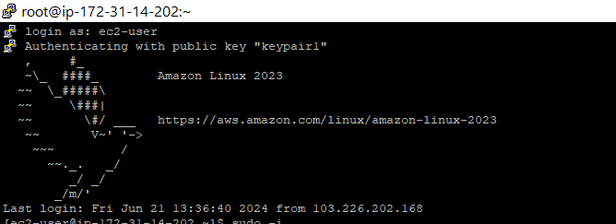

* **$--- sudo -i**



**# yum install httpd\***

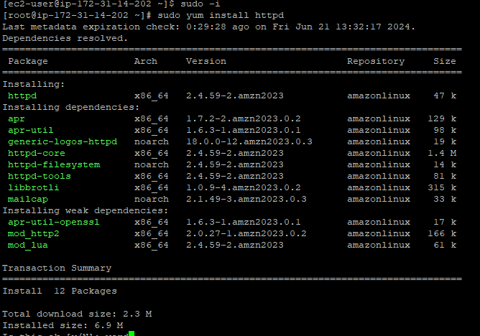

* **Is this okay ? N/Y-----press - y** 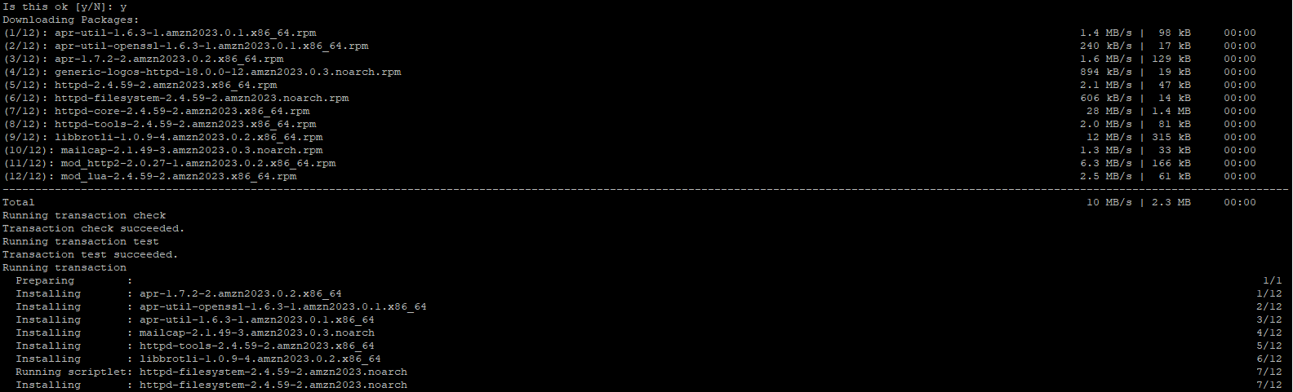



* **rpm -qa**

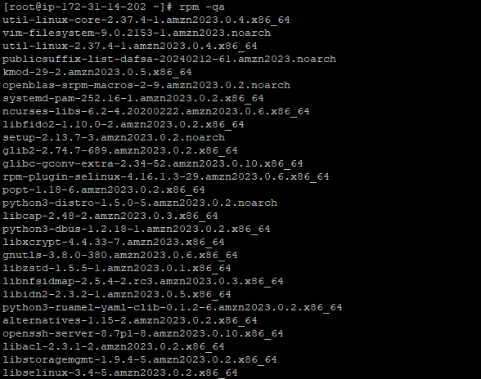

* **service httpd start**



* **service httpd status**

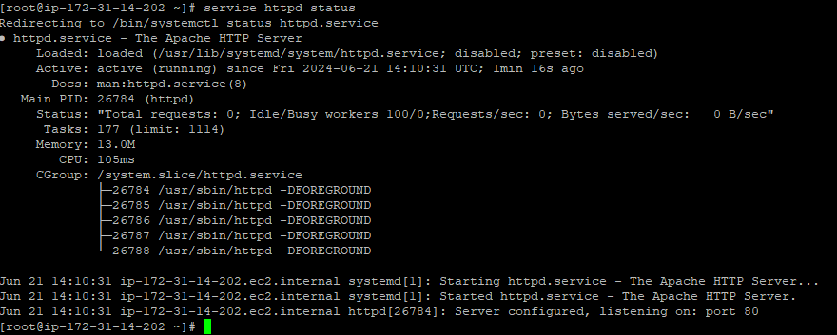

**Check the server by copied IP in url or browser if it will work then it shows like this :**

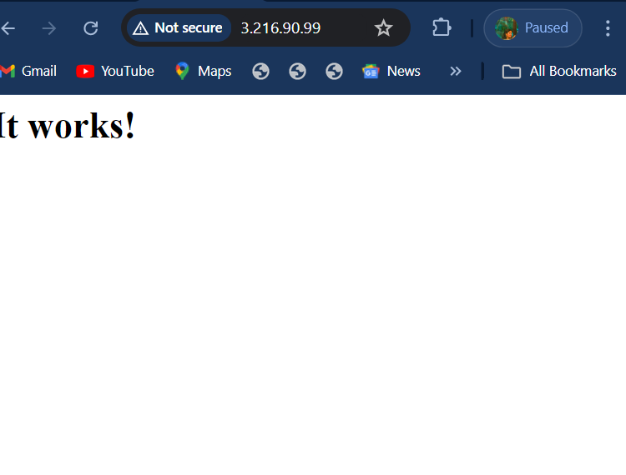

* **/var/www/html**



* **# echo "My First Web Page" > index.html**

**-------then add some content inside of this new index.html file**

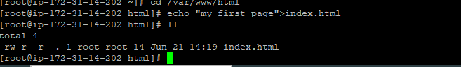

**it will show like this.**

